**Practical 5:**

**Aim: Perform simulation of FP-Growth algorithm.**

**Solution:**

**Using supermarket.arff**

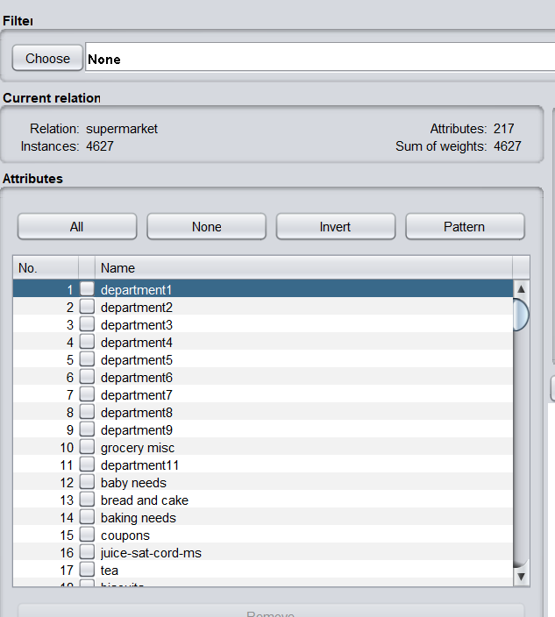

**Selecting FPGrowth algorithm and configuring parameters**

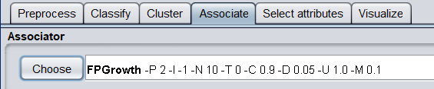

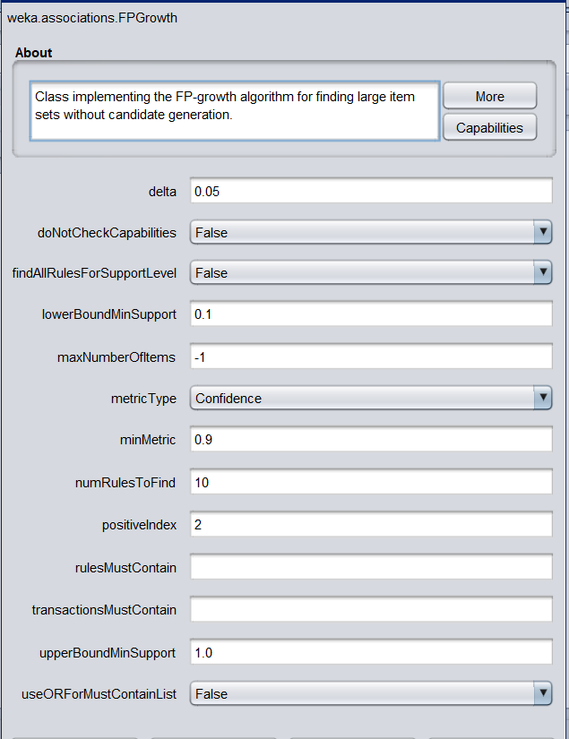

**Output:**

